

**SANYO 2.0 Ton RQC25C**

**Rs. 88,700/-**

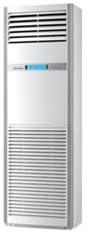

**Product Features**

* precise system control technology
* concealed LED display
* Intelligent airflow
* precise system control technology
* friendly referigerant R410a

**Specification**

**Type** Wall Mounted Split AC

**Cooling (Btu/h)** 37000

**Voltage (V)** 220-240

**Power Input (W)** 2100

**EER (Btu/W-h-W/W)** 6.7-1.8